**Comparison of the Vona du Toit Theory with Other Theories on Motivation and Action**

**Elisabeth Holsten**

**Published in the "Vona and Marie du Toit Creative Ability Workshop" - conducted on the 3, 4 & 5 August, 1994 in cooperation with the Departments of Occupational Therapy. MEDUNSA and the University of Pretoria**

**INTRODUCTION**

Reviewing literature for this topic, I realised how much has been written inside and outside Occupational Therapy. I limit myself to the comparison of Vona du Toit’s model with the most important developments in Occupational Therapy.

When Occupational Therapists still focused on the medical model, Vona already sensed that the profession needed a different science to support the practice of Occupational Therapy. She also realised that this science, in some or other way had to be related to **“activity”**. As from 1967, the concept of **“creative ability”** was developed.

The theory of creative ability will be compared with 8 important theories in Occupational Therapy.



|  |  |
| --- | --- |
| CREATIVE ABILITY  MOTIVATION  AND  ACTION | THEORIES OF:  MOTIVATION  HUMAN OCCUPATION  THE ADAPTIVE PROCESS  OCCUPATIONAL ADAPTION  ROLE OF ENVIRONMENT  ENABLEMENT  OCCUPATIONAL COMPETENCE  A SCIENCE OF OCCUPATION |

1. **MOTIVATION**

The importance of motivation has never ever been doubted in Occupational Therapy. Mainly 3 aspects should be of interest to us:

* 1. What motivates people?
  2. How strong is this motivation?
  3. Treatment strategies to elicit motivation

But most theorists, inside or outside Occupational Therapy consider only

***“What motivates people?***

Some address the matter of extrinsic motivation, others that of intrinsic motivation. Very interesting theories on what motivates people exist, e.g. Freud, Jung, Maslow, etc.

At the end of the sixties and the beginning of the seventies, we find the first Occupational Therapy theorists (in literature) who describe the importance of intrinsic motivation. Reilly, and later Kielhofner and Burke describe *intrinsic motivation as a biologically inherent of innate urge to explore and master the environment – through occupation.*

Since this intrinsic motivation is the underlying dynamic of Occupational Behaviour, it is this aspect of motivation which is most relevant to the practice of Occupational Therapy.

Long before this development, Vona had already reached a quite different conclusion:

* She agreed on motivation being an inner drive (= intrinsic motivation).
* By defining and describing the levels of motivation and action, she attended to not only what motivated people, but also to the strength of motivation.
* She determined that we could **measure** this motivation in action and that through action, motivation could be influenced.
* In addition, for the first time in history, clear treatment strategies were described.

In summary – Vona attended to all three questions regarding motivation in Occupational Therapy.

What has happened since Vona’s time? I would like to present a more recent theory on Motivation by **Susan Doble** in 1986, which confirms many of Vona’s thoughts nearly 20 years later. Her and other following theories concentrate mainly on treatment strategies.

In her article on ***“Intrinsic Motivation”,***it is indicated that an individual may demonstrate varying levels of motivation (strength of motivation). She uses the levels as:

* Exploratory
* Competence, or
* Achievement orientated behaviour.

She believes that Occupational Therapists have the capacity to develop a client’s intrinsic motivation by:

* Influencing the task environment
* Ensuring meaningfulness of task
* Facilitating experiencing personal control
* Generating feelings of competency.

This model is different but compatible with Vona’s model.

**Susan Arnsten**, not being aware of this model, also indicated the importance of personal causation or personal control, the importance of a structured environment, the importance of success.

Another interesting though comes from **David Jeffrey** (1981). ***Human motivation can be effectively increased and sustained by applying the principle of cognitive clarity.*** By demonstrating a clear path of achievable sub-goals, the counsellor ensures that the process of reaching these sub-goals and eventually the main goal itself becomes believable and self-reinforcing.

|  |
| --- |
| **MODEL OF INTRINSIC MOTIVATION**  Susan Doble: 1986 |
| **LEVELS OF MOTIVATION:**   1. **EXPLORATORY / INVESTIGATORY** 2. **COMPETENCE ORIENTED** 3. **ACHIEVEMENT ORIENTED** |
| **DEVELOPMENT OF INTRINSIC MOTIVATION BY:**   1. **INFLUENCING THE TASK ENVIRONMENT** 2. **ENSURING MEANINGFULNESS OF TASK** 3. **EXPERIENCING PERSONAL CONTROL** 4. **GENERATING FEELINGS OF COMPETENCY** |

1. **THEORIES OF HUMAN OCCUPATION**

Theories around the concept **Human Occupation** started to develop at the same time as Vona’s model on **Creative Ability** as a result of:

* dissatisfaction with the medical model as the basis of Occupational Therapy
* a conviction that there was more to the use of activities that was evident at that moment in time.

Mary Reilly developed a framework of ideas around the concept of Occupational Behaviour during the 1960’s. Kielhofner was a student of Mary Reilly and developed a more detailed model. I refer to the schematic diagram of the following model.

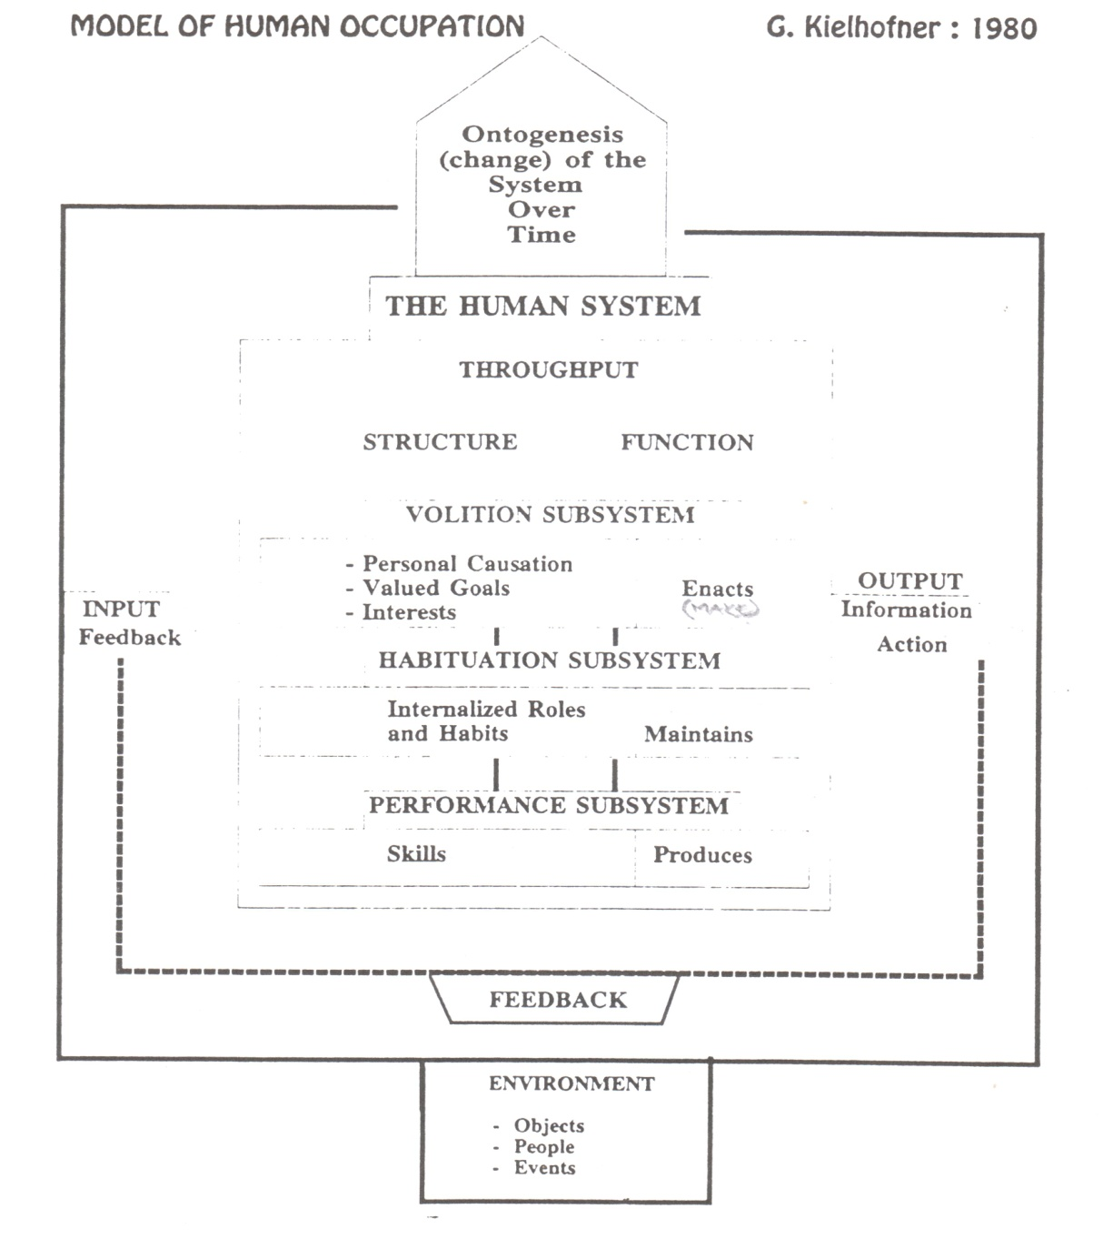

**COMPARISON OF THE MODEL OF HUMAN OCCUPATION WITH VONA DU TOIT’S THEORY ON CREATIVE ABILITY**

1. The terms Human Occupation: Active Participation

Creative Participation

Creative Ability

indicate the same theoretical premises.

1. Kielhofner and others have stated that the goal of human life is to adapt to and master our environment and actualize ourselves. We achieve this goal by taking part in various occupations / activities.

Vona du Toit went one step further: She claims that each person’s ability to master his environment and actualize himself depends on his creative capacity / potential and more so on his creative ability (that is the potential that is actualized).

1. Where Kielhofner describes 3 sub-systems of Occupational Behaviour, Vona du Toit describes only 2, namely motivation and action. The subsystems of volition and motivation are identical but Vona classifies motivation on the strength of motivation, whereas Kielhofner describes **what** motivates people.

Vona du Toit’s Task Performance is similar to the Perceptual – Motor and Process skills of Kielhofner’s. Vona du Toit describes in some detail the abilities required for Task Performance; Kielhofner not. The same applies to Interpersonal abilities and Communication skills.

Credit must be given to the description of Kielhofner’s Habituation sub-system. This system is of extreme importance to Occupational Therapy. Vona, I think, sensed the importance of something wider that Task Performance, in her description of handling of situations and events.

1. The Role of the Environment is important to both.
2. Both describe and open system which makes allowance for change.
3. Both use levels to measure output in work, leisure and personal management.

**Kielhofner** **Vona du Toit**

Exploration Exploration

Competency Participation

Achievement Mastering

Vona sub-classifies into the well known levels.

1. Both indicate **satisfaction** as a measure of mastery.
2. Both have clinical application in assessment and treatment, although Vona, due to further sub-classification, goes into far more detail, and is a precise tool.
3. Both have application in all clinical settings – some researched, others not.
   1. **ADAPTIVE RESPONSE THEORIES**

Although the concept of adaptation had been indicated by Kielhofner, the Filer’s and others, the importance of adaptation in Occupational Therapy was for the first time discussed by Lorna Jean King in ***“Towards and Adaptive Response”***.

The close connection between Adaptation and Occupation was realized – that is **Adaptation takes place through occupation.**

The following diagram indicates the 4 characteristics of individual adaptation as described by Lorna Jean King.

**A SYSTEMS MODEL OF AN ADAPTIVE PRICESS**

L.J. King: 1978

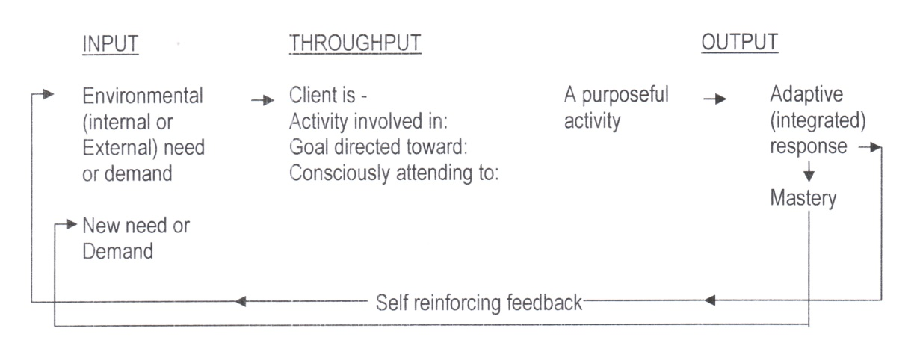

|  |
| --- |
| 4 CHARACTERISTICS OF INDIVIDUAL ADAPTATION |
| 1. INDIVIDUAL’S ACTIVE PARTICIPATION 2. ENVIRONMENTAL DEMANDS, NEED,S TASKS, GOALS EVOKE RESPONSE 3. RESPONSE ORGANIZED AT SUBCORTICAL LEVEL 4. SUCCESSFUL RESPONSE REINFORCES |

Comparing it to Vona’s theory, one notices similarities:

Both stress:

* Active purposeful activity participation
* The successful response as reinforce of the process.

Vona however describes this as a creative response and not an adaptive response.

1. **THEORY ON OCCUPATIONAL ADAPTATION**

Occupational Therapists now become very aware of adaptation in Occupational Therapy. Clark, Mosey, Gilfoyle and Gradey, Keinnman and Bulkley and perhaps many more, attempted to describe this phenomenon. As from the middle eighties, an important new development took place: ***“Adaptation through Occupation”.*** Two models will be discussed:

* 1. **Adaptation Through Occupation Model by Kathlyn Reed (1984)**

This model is of some importance as Reed strives to summarize all existing models. Let’s just have a brief look at this model:

**MODEL: ADAPTATION THROUGH OCCUPATION**

K. Reed: 1984

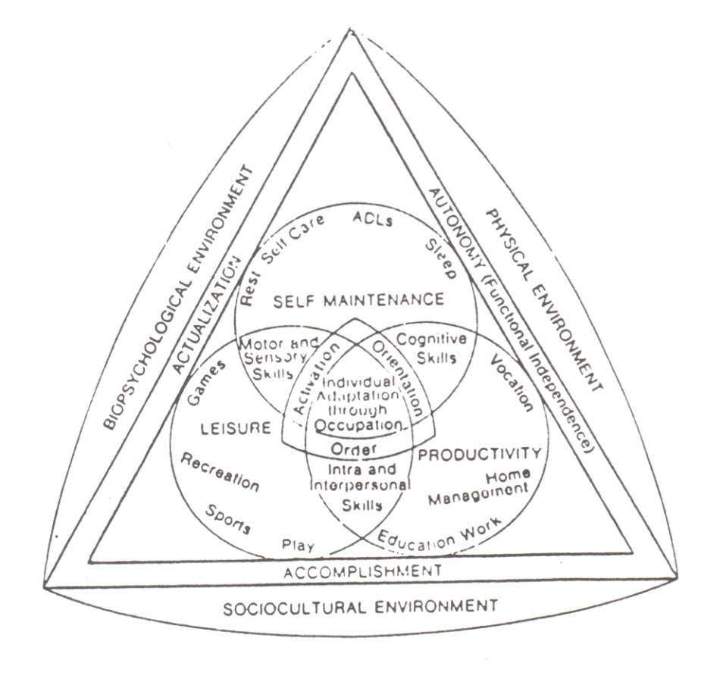

**I don’t know if the type in this diagram is legible, but I have no clue how to draw it**

Again we find similarities with Vona du Toit’s theory.

1. **Reed** aims at Individual Adaptation through Occupation

**Vona** aims at Growth of Creative Ability through Activity Participation

Perhaps these are similar concepts?

1. Endpoint such as anatomy (independence), actualization (self satisfaction) and accomplishment (doing required things well) seem to fit in well with Vona’s norm direction, independence and satisfaction.
2. Over time the role of the environment has become more and more important. Reed describes it in more detail than Vona du Toit.
3. At this moment of time, Occupational areas and Performance areas have become accepted terms.

The time models by e.g. Nelson, lead the way to: (follows on next page)

* 1. ***“Occupational Adaptation Process Model”* by J.K. Schkade and S. Schultz (September 1992)**

The similarities between this model and Vona’s theory are incredible.

**ADAPTATION THROUGH OCCUPATION MODEL**

**ANALYSIS OF MODEL**

K. Reed 1984

|  |  |  |  |
| --- | --- | --- | --- |
| ANALYSIS OF THE MODEL | | | |
| Final Outcome  End Points  Facilitators and  Inhibitors  Directions and  Controls  Occupational Areas  Performance  Areas    General  Elements  Specific  Elements  Initiating or  Trigger mechanisms | ]  }  } Outcomes  }  }  } | Individual Adaptation  Through Occupation  Autonomy, Actualization  Accomplishment  Physical environment  Psychobiological environment  Socio-cultural environment  Needs  Demands  Self maintenance  Productivity  Leisure  Motor  Sensory  Cognitive  Intrapersonal  Interpersonal  Knowledge  Abilities  Attitudes / Values  Orientation  Activation  Order  Reflexes and  Exploration | }  } Adaptive  } responses  } coping skills  } |

**MODEL: OCCCUPATIONAL ADAPTATION PROCESS**

J.K. Schkade & S Schultz: September 1992

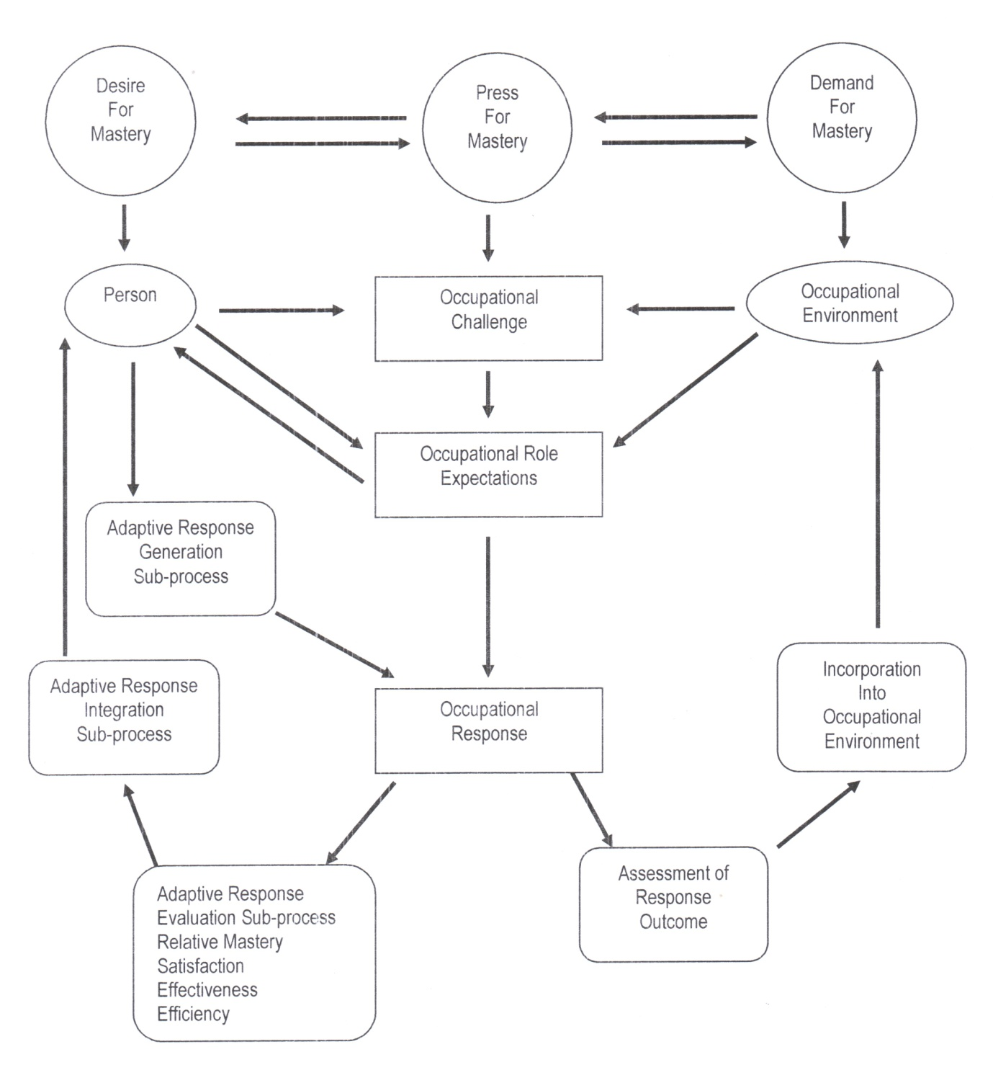

Where the one person talks of a **creative process** – the other describes an **adaptive response.** Both take place through occupation / activity. In both approaches –

1. Growth / change takes place where a challenge is met. Challenges come from within a person or from the environment.
2. There is generation of response:

* Planning of effort / energy
* Planning of method using applicable performance components.

1. There is an adaptive response / creative act.
2. An evaluation takes place in terms of:

**Schkade & Schultz:** Relative Mastery in terms of

* Efficiency
* Effectiveness
* Satisfaction.

**Vona du Toit:**

* Norm direction
* Satisfaction
* Control of Anxiety
* Maximum Effort
* Initiative.

1. There is feedback to the self and the environment.
2. Growth of creative ability / occupational adaptation occurs in the presence of ***“relative mastery”***.

Two big differences –

1. Vona describes levels of creative ability in detail.
2. Treatment strategies described by Vona du Toit are well formulated; the OA model’s strategies are vague.
3. **THE ROLE OF THE ENVIRONMENT**

As early as 1968, Watanabe (see below) indicated the importance of the environment in her definition of

* life space
* life tasks
* mastery of both
* responsibility to self and others in one’s environment

**FOUR CONEPTS BASIC TO THE**

**OCCUPATIONAL THERAPY PROCESS**

S.Watanabe: 1968

INTRODUCED CONCEPTS OF:

LIFE SPACE

MASTERY

RESPONSIBILITY

LIFE TASKS

Although the role of the environment was discussed almost in all models such as Reed and Kielhofner, I want to present an interesting one:

The **‘*Ecological Systems Model for Occupational Therapy* by M. Howe & A. Briggs (1982)**

**ECOLOGICAL SYSTEMS MODEL FOR**

**OCCUPATIONAL THERAPY**

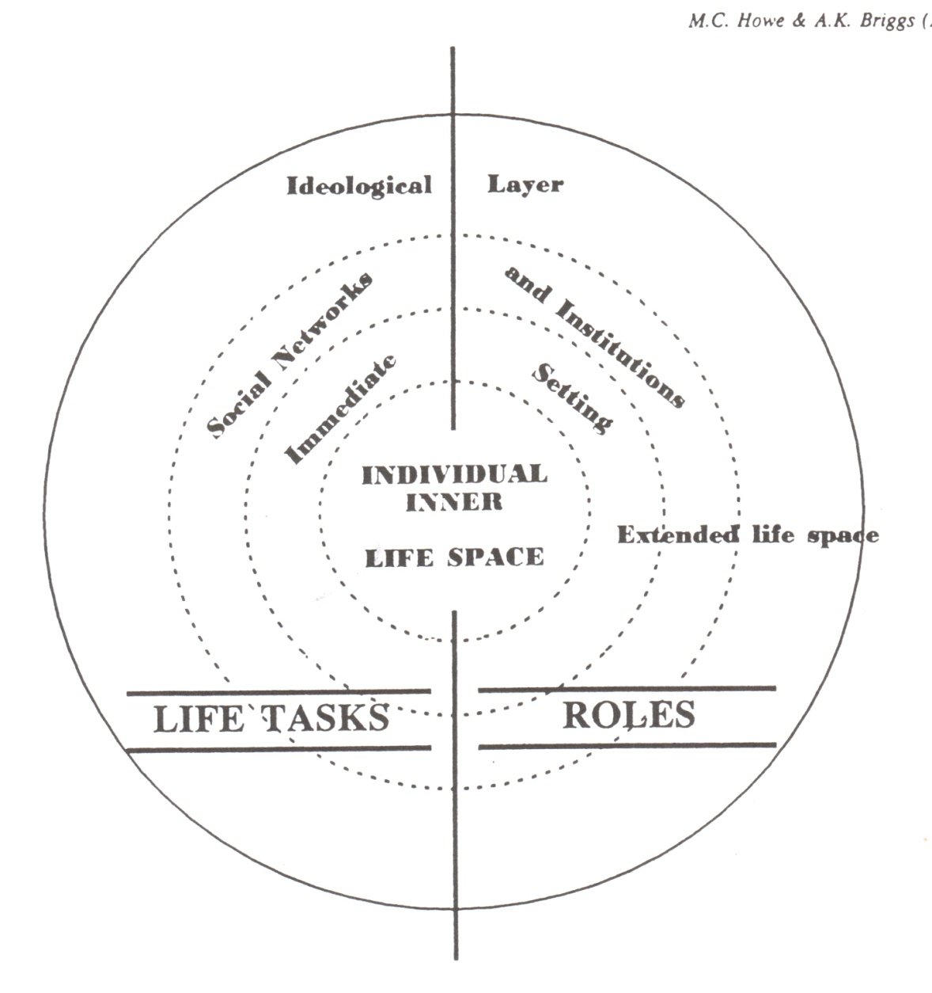

There are interesting similarities with Watanabe’s model. The developing individual is viewed as an open system interacting with the environment. Function or dysfunction is evaluated in terms of a **person’s effectiveness in achieving their own goals, for their own quality of life and in their interactions with the environment.** If performance of necessary tasks and roles is in harmony with needs and goals of external systems, then behaviour is functional.

Vona viewed the environment as important – but the emphasis was still more on the individual. Since her time, the environment has started to play a far more important role.

1. **THEORIES: ENABLEMENT / DISABLEMENT**

Traditionally, Occupational Therapy has been located in a health context and has been closely associated with medicine – that is **with a Disablement Model.** In her Enablement / Disablement Model of 1992, H. Polatajko pleads for Occupational Therapy within an enablement model. By looking at disablement, we might in actual fact miss a lot.

**THE ENABLEMENT MODEL**

Helen Polatajako: 1992

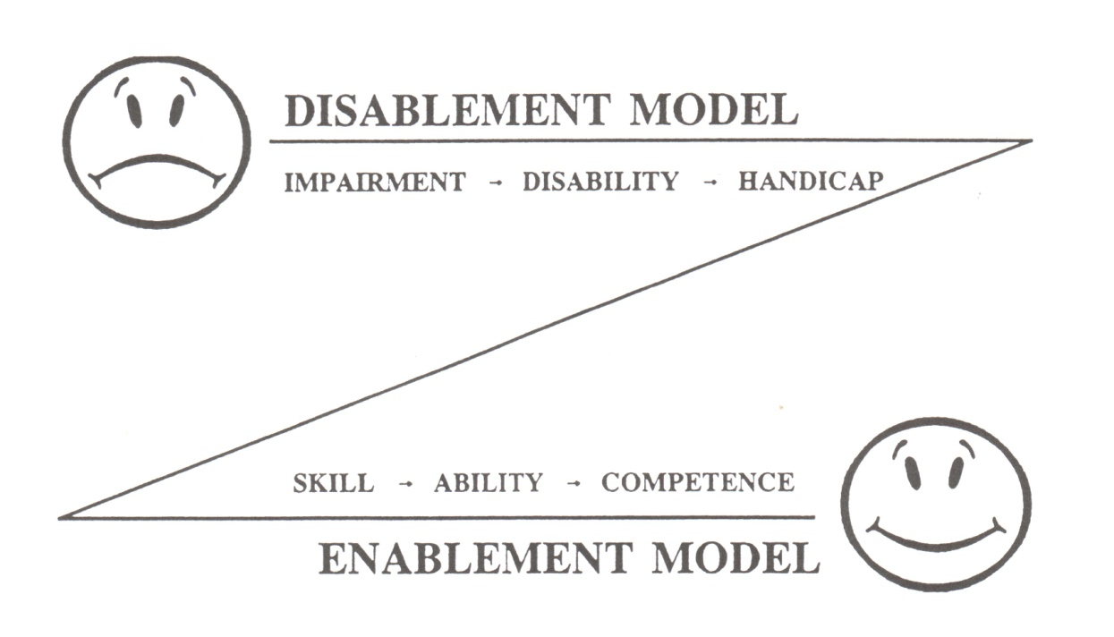

Vona, by emphasising the importance of facilitation of Creative growth and growth in activity function, had already moved away from the medical model. Like no one before her, she became aware of no matter how little residual ability – there is still ability, there can be growth.

1. **OCCUPATIONAL COMPETENCE**

In her theory of creative ability, she describes competence in relation to the individual. An interesting development can be observed in Helen Polatajko’s model on ***“Occupational Competence”*** of 1992 (as indicated below).

**THE OCCUPATIONAL**

**COMPETENCE MODEL**

Helen Polatajko: 1992

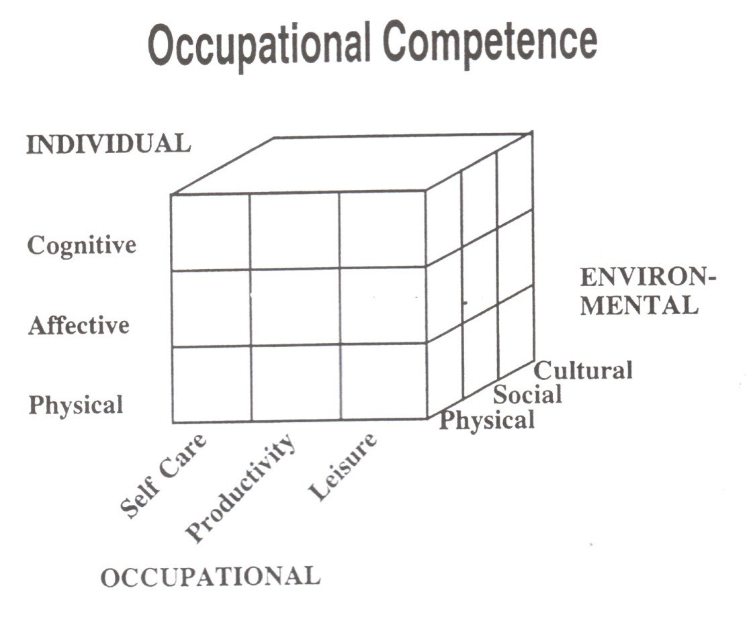

**Interaction Between the Ability of the Individual and**

**the Environment**

**_________________________________________________**

**COMPETENCE –**

**ABILITY X ENVIRONEMENT**

Occupational competence is not viewed only as competence of an individual in isolation – there is only competence, if there is interaction between the ability of the individual and the environment. Once again, we as Occupational Therapists have to focus on both the individual and the environment.

1. **TOWARDS A SCIENCE OF OCCUPATION**

For years, Occupational Therapists have been aware of the fact that we need a substantial theory to support the practice and study of Occupational Therapy. All Vona’s efforts can be seen in this light.

I think she would have been proud and perhaps have been part of the development towards a ***“Science of Occupation”***. It is perhaps surprising that ***“occupation”*** has not until now, formed a central theme in humanistic enquiry. Perhaps the traditional scientific methods of enquiry were not suitable for exploration of such a complex and dynamic entity as human occupation.

The present interest by Yerxsa et al., in ***“A Science of Occupation”*** can be traced from the inspirational work of Mary Reilly at the USC. Her successors have continued the exploration she began.

What is then meant by *“A Science of Occupation”?*

**TOWARDS A SCIENCE OF OCCUPATION**

**OCCUPATIONAL SCIENCE IS A NEW INTERDISCIPLINARY**

**SYNTHESIS OF BASIC KNOWLEDGE CONCERNING THE HUMAN**

**AS AN OCCUPATIONAL BEING.**

**WHY?**

**IS OCCUPATION SO IMPORTANT?**

**OCCUPATION WHICH IS CULTURALLY SANCTIONED, MAY BE**

**SEEN AS A PRIMARY ORGANIZER OF TIME AND RESOURCES,**

**ENABLING HUMANS TO SURVIVE, CONTROL AND ADAPT TO**

**THEIR WORLD, BE ECONOMICALLY SELF-SUFFICIENT AND TO**

**EXPERIENCE SOCIAL RELAIONSHIPS AND APPROVAL, AS**

**WELL AS PERSONAL GROWTH.**

In conclusion, I once more want to express my admiration for Vona’s ideas, thoughts, her work and my gratitude for having known her, being her student. The insight she had, almost 30 years ago! It is incredible!

Occupational Adaption and Creative Ability are similar, but they are not the same. Could we as South African Occupational Therapists not add a cherry on the top?

***“Creative adaption through Occupation”,***

**One final comment:**

The main contribution of Vona’s levels of motivation and action is our ability to assess and treat occupational functioning as a whole. Let us now put this theory into practice – scientifically!